**U.S. Department of Energy (DOE)  
Clean Energy to Communities (C2C) Program**

Summary of Technical Assistance (TA) Support

|  |
| --- |
| Marker with solid fill |
| Icon  Description automatically generatedBuildings |
| Icon  Description automatically generatedClean Power |
| Climate Mitigation and Resilience |
| Cross-Sectoral Justice |
| A picture containing text, clipart  Description automatically generatedJobs and Economic Development |
| Icon  Description automatically generatedMobility |

**Lyons, Colorado**

TA Scope

From July 2023 through January 2024, Lawrence Berkely National Laboratory (LBNL) provided technical input regarding financial models, including ownership by the Town of Lyons (“Lyons”), Colorado, and a third party-owned solar power purchase agreement. LBNL reviewed the federal Production Tax Credit, Investment Tax Credit, and Modified Accelerated Cost Recovery System using the National Renewable Energy Laboratory’s (NREL) System Advisor Model. LBNL then provided comments on Lyon’s request for proposals. Comments focused on the procurement and technical design of the proposed project.

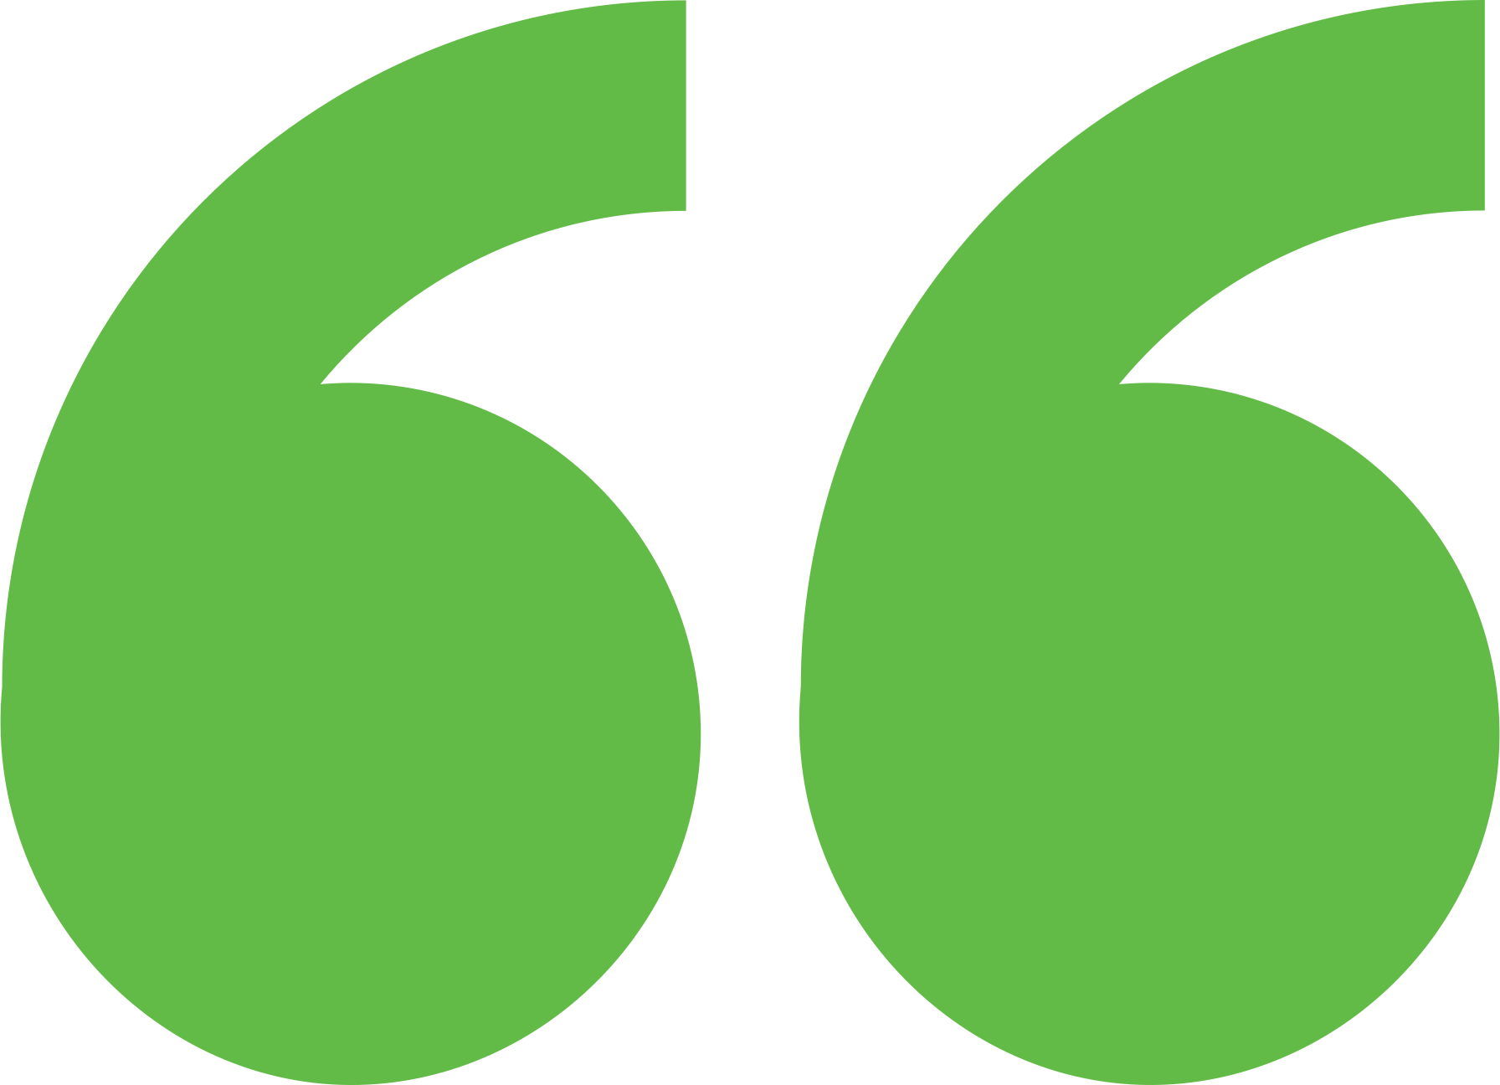 Impact

The support offered through Expert Match provided decision support to Lyons during discussions and deliberations with the grant-maker, as well as during the project bidding process. The participant from Lyons stated: “We moved forward with putting out a request for proposal (RFP) for our solar generation and storage facility. Feeling confident that we should try to move forward with our project.”

Background

Photo goes here.

*Delete this box before publishing.*

**Background**

Ann Arbor is a city of approximately 122,000 people located in southeast Michigan. The city and its residents are leaders in sustainability and climate action. Their A2ZERO Climate Action Plan outlines their just transition pathway to community-wide carbon neutrality by 2030. With equity as a focus, they are implementing strategies to improve home energy efficiency (EE) and electrify appliances. Toward this, the city wants to explore community geothermal heating and cooling to serve a variety of building types including rental and affordable housing. The city has applied to DOE’s Geothermal Heating and Cooling Design and Deployment program and garnered the support of City Council to pursue these projects, but they need to understand the concept’s feasibility in order to make a “go, no-go” decision.

Colorado’s Department of Local Affairs (DOLA) recently advised Lyons that the Renewable and Clean Energy Initiative grant funding they were awarded was being extended to June 2025. Lyons is not sure whether the increased construction costs and the ability to receive the federal Solar Investment Tax Credit still make the project feasible. Lyons sought expert advice on the feasibility of the project and the best combination of solar and energy storage.

Expert Match Team

**Sofia Garcia George**  
Community Lead, Main Expert Match Point of Contact, NREL

**Gerald Robinson**  
Researcher, LBNL

**Christopher Payne**  
Senior Researcher, LBNL

**Sika Gadzanku**  
C2C Expert Match Program Manager, NREL

Community Team

**Aaron Caplan**  
Utilities Director

**Jim Kerr**  
Chair of Utilities and Engineering Board

**Jane Allo**  
Member of Utilities and Engineering Board

For more information, visit:  
**energy.gov/eere/clean-energy-communities-program**

August 2024